Understand and Implement Network Topologies
Local Area Network (LAN) Design for the Healthcare IAM Operations Home Lab
Prepared by Sabitha S Karanavar

1. Introduction
This report satisfies the project rubric item “Understand and Implement Network Topologies” for the Healthcare IAM Operations Home Lab. The lab simulates a 30-employee hospital environment used to practice identity and access management (IAM) operations: on-premises Active Directory, Microsoft Entra ID, role-based access control (RBAC), the joiner-mover-leaver (JML) lifecycle, and access reviews. Because every one of those activities depends on a working network underneath it, this report documents the single network configuration chosen for the lab, explains why it fits the project, and shows how it supports secure communication and centralized network management.

2. Topology Selection and Justification
Four broad network configurations were available: Local Area Network (LAN), Wide Area Network (WAN), Metropolitan Area Network (MAN), and Personal Area Network (PAN). A WAN or MAN was not appropriate because the lab represents a single facility with no geographically separated sites to connect, and a PAN is scoped too small — built around one person's personal devices rather than an organization's shared infrastructure. The lab's scope (one hospital, one physical location, all VirtualBox-hosted VMs on the same virtual network segment) matches a LAN: a network confined to a single site where a defined group of devices share centralized services.
Topology within the LAN: Within that LAN, a star topology was chosen, meaning every device connects through a single central point — the core switch — rather than to each other directly. This mirrors how the lab is actually built: the Domain Controller, file/application server, and every department workstation each have one link back to a shared switch, and Windows Server’s own architecture (a central Domain Controller that every client authenticates against) is inherently star-shaped. A star topology was preferred over alternatives such as bus or ring because it isolates faults to a single link, scales cleanly as new departments or roles are added (as happened in Weeks 8–9 of the project when Security, Reception, and Contractor roles were built out), and is the standard design pattern for enterprise and healthcare networks that must support VLAN segmentation.

3. Network Topology Diagram
Figure 1 shows the LAN star topology implemented for the lab. The Domain Controller, file/application server, and a test client sit on the left as core infrastructure. A perimeter firewall provides the LAN's single controlled exit to the Internet and, from there, an encrypted (TLS/HTTPS) connection to the Microsoft Entra ID cloud tenant used for hybrid identity, MFA, and Conditional Access. On the right, three logical VLANs branch from the core switch, one per functional grouping of departments identified in the project's RBAC design: Clinical, Administrative, and IT & Security.
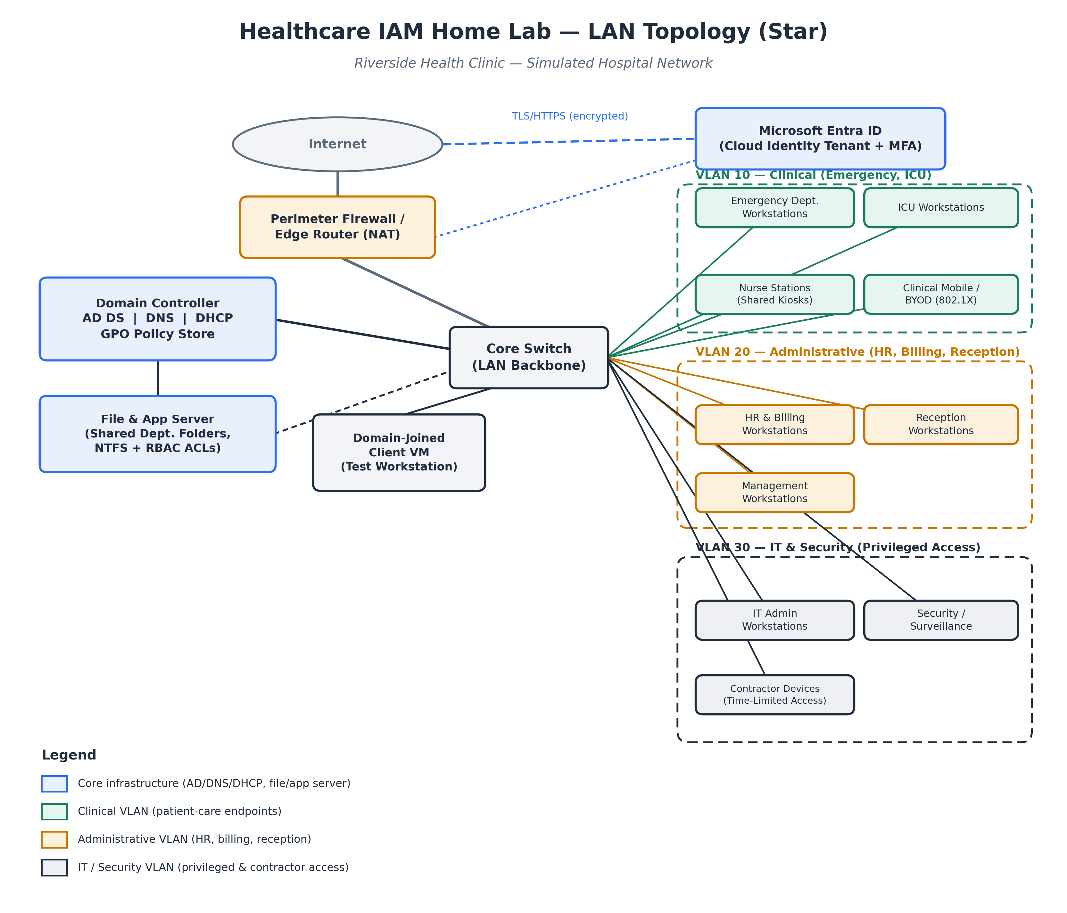
Figure 1. LAN star topology for the Healthcare IAM Home Lab.
Note: department and organization names shown are illustrative and follow the roles referenced throughout the project plan (Emergency, ICU, HR/Billing, Reception, Security, IT, and Contractors). Substitute the exact organization name and department list finalized in the Week 1 scenario write-up before final submission.

4. Component Overview
Component | Network Role | IAM / Security Function
Perimeter Firewall / Edge Router | Filters and NATs all traffic between the internal LAN and the Internet. | Only outbound HTTPS/TLS to Microsoft Entra ID is permitted; blocks unsolicited inbound connections.
Core Switch (LAN backbone) | Central hub of the star topology; every device connects to it directly. | Isolates faults and traffic per link; supports VLAN tagging to separate department traffic.
Domain Controller (AD DS, DNS, DHCP, GPO) | Authenticates users/devices and centrally issues addresses, names, and policy. | Enforces Kerberos authentication, password/lockout policy, and OU-based administration.
File & Application Server | Hosts department shared folders that simulate line-of-business applications. | NTFS permissions bound to AD security groups enforce the RBAC matrix.
Domain-Joined Client VM | Represents a standard end-user workstation. | Used to validate login, GPO application, and access-chain testing.
Clinical VLAN (Emergency, ICU, nursing) | Segment for patient-care endpoints, including shared kiosks and mobile devices. | Isolated from administrative traffic; 802.1X authentication for mobile/BYOD devices.
Administrative VLAN (HR, Billing, Reception, Management) | Segment for business-operations endpoints. | Separated from clinical data paths to reduce exposure of patient information.
IT & Security VLAN (privileged and contractor access) | Segment for administrative, security, and time-limited contractor devices. | Highest scrutiny segment; contractor accounts carry expiration dates and tighter review.
Microsoft Entra ID | Cloud identity tenant extending the on-prem directory. | Provides MFA, Conditional Access, and cloud application assignment over an encrypted channel.

5. How This Topology Supports Secure Communication
Perimeter control and encrypted cloud extension. The firewall/edge router is the LAN's only path to the Internet, so all traffic leaving the network — including the connection to Microsoft Entra ID — passes through one controlled, filtered point. The Entra ID link itself runs over TLS/HTTPS, and privileged or cloud sign-ins additionally require multi-factor authentication (MFA) and Conditional Access, so even an intercepted session token is far less useful to an attacker.
VLAN segmentation limits lateral movement. Separating Clinical, Administrative, and IT & Security traffic into distinct VLANs means a compromised device in one segment cannot directly reach hosts in another without passing back through the switch's routing/ACL rules. This matters in a healthcare context specifically: if a clinical workstation were compromised, segmentation helps contain the exposure of patient-facing systems from HR, billing, and administrative data.
Centralized, ticket-based authentication. Because every endpoint has a single, direct link back to the Domain Controller (the defining property of a star topology), all authentication flows through one trusted source using Kerberos, which relies on time-limited tickets rather than transmitting passwords across the network. This is the same mechanism validated in the project's end-to-end access testing (domain login → group-based app access).
Access enforced at the file-share layer. NTFS permissions on the shared department folders are bound to the same security groups used in the RBAC matrix, so the network layer and the access-control layer reinforce each other — a user who is on the correct VLAN still only sees the files their group membership allows.
Consistent security baselines. Group Policy Objects (password complexity, minimum length, lockout threshold, expiration) apply uniformly because every device is one hop from the Domain Controller. There is no branch of the network that can silently fall out of policy, which is what the project's periodic access reviews (Weeks 7 and 10) are designed to confirm.

6. How This Topology Supports Network Management
Single point of administration. A star topology's hub — here, the Domain Controller behind the core switch — gives administrators one place to create, modify, and remove accounts, groups, and policies. This is what makes the joiner-mover-leaver activities in the project (onboarding, transfer, termination) executable as a handful of AD/Entra actions rather than device-by-device changes.
Fast fault isolation and troubleshooting. Because each device has its own dedicated link to the switch, a cable, port, or endpoint failure affects only that one connection; the rest of the LAN, and all other VLANs, keep functioning. Problems are also easier to trace: administrators can check the single link between the switch and the affected device rather than tracing a shared bus or ring.
Scales without redesign. Adding a new role, workstation, or department — as the project did when it built out Security, Reception, and Contractor access in Weeks 8 and 9 — only requires adding a new spoke (and, if needed, a VLAN membership) to the existing switch. The core design does not change.
Automation and monitoring have one target. The PowerShell scripts built in Week 8 (querying users and groups, automating account creation and deprovisioning) all run against the same central Domain Controller that every endpoint already trusts. Centralizing the topology around that hub is what makes those scripts capable of managing the entire environment from one console, and what makes access reviews (comparing current group membership against the RBAC baseline) a single query rather than a device-by-device audit.

7. Conclusion
A single-site star-topology LAN, segmented into Clinical, Administrative, and IT & Security VLANs and extended to Microsoft Entra ID over an encrypted connection, matches both the physical scope of the Healthcare IAM Home Lab and the operational goals of the project. It gives every identity and access management activity performed in the lab — onboarding, transfers, terminations, MFA support, and access reviews — a predictable, centrally administered network to run on, while VLAN segmentation and centralized authentication provide the secure-communication properties expected of a healthcare environment handling sensitive data.

